**CERTIFICATE**

*This is to certify that Mr./Ms.* ***….... Hemil…Chovatiya.............*** *with enrolment no.* ***..........200303108003.................*** *has successfully completed* ***his****/her laboratory experiments in the*  ***JAVA PROGRAMMING WORKSHOP (******203105259)***  *from the department of* ***........Information Technology(4ITA1)….….........*** *during the academic year* ***........2021-2022.........***



Date of Submission: ......................... Staff In charge: ...........................

Head of Department: ...........................................

**Practical Set: 1**

**Basics of Java**

**Practical 1:**

**AIM:** **Prepare a report on how to set the PATH variable to the java directory.**

**Steps:**

1. Open Control Panel and go to System and Secutiry

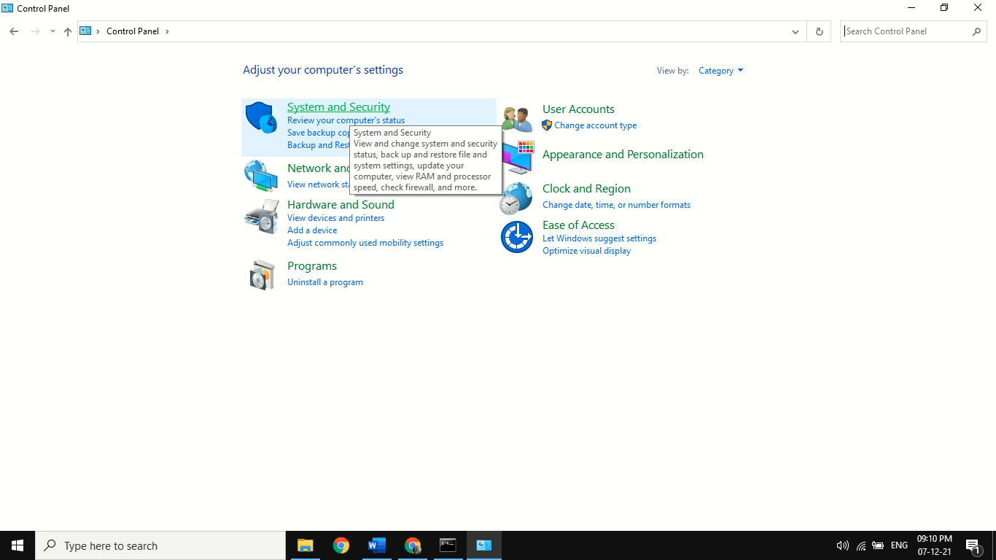

1. Go to System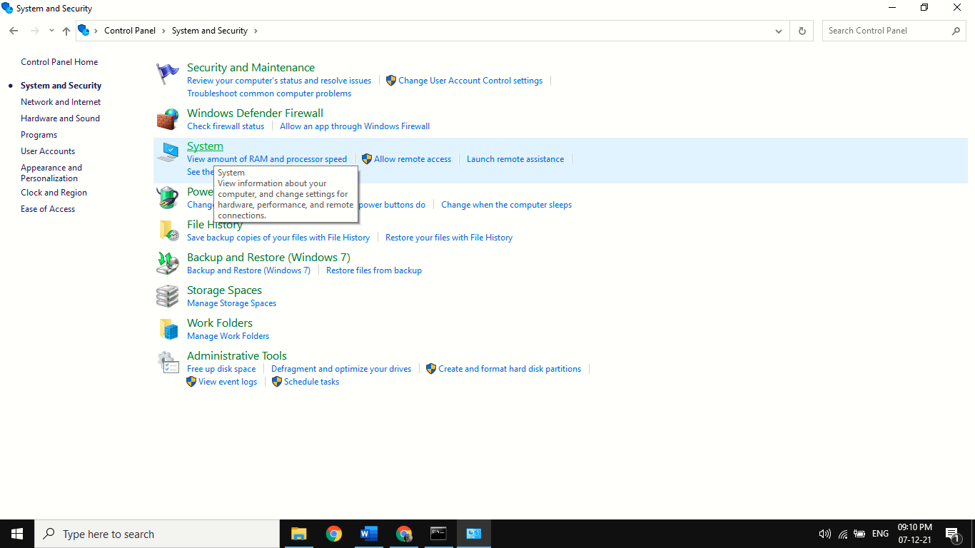
2. Go to Advanced System Setting

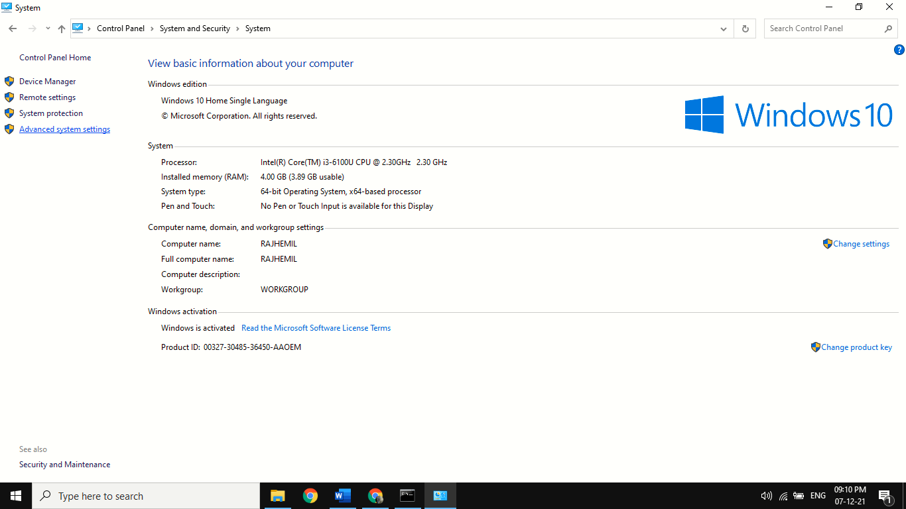

1. Go to Environment Variables

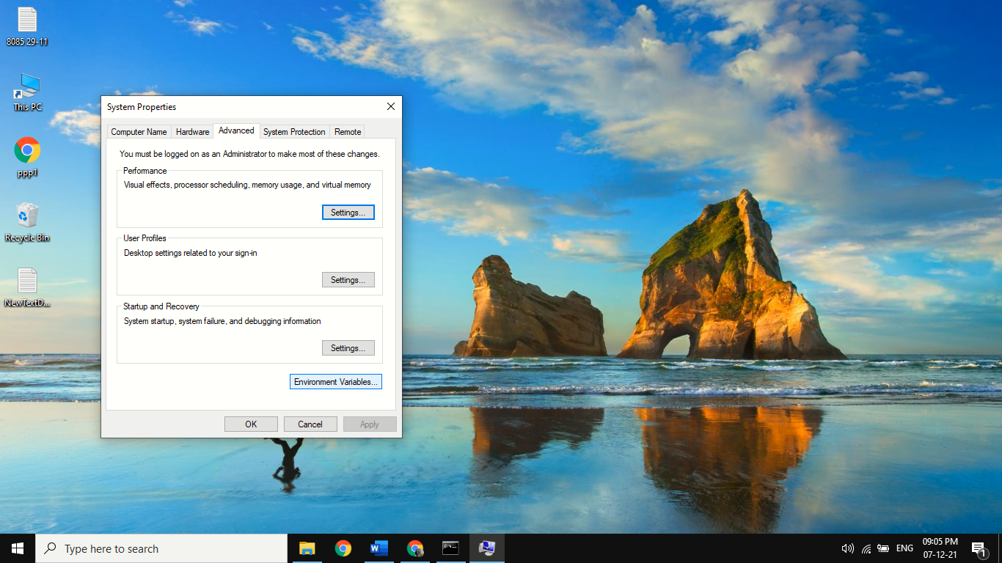

1. Click on path and then click on edit

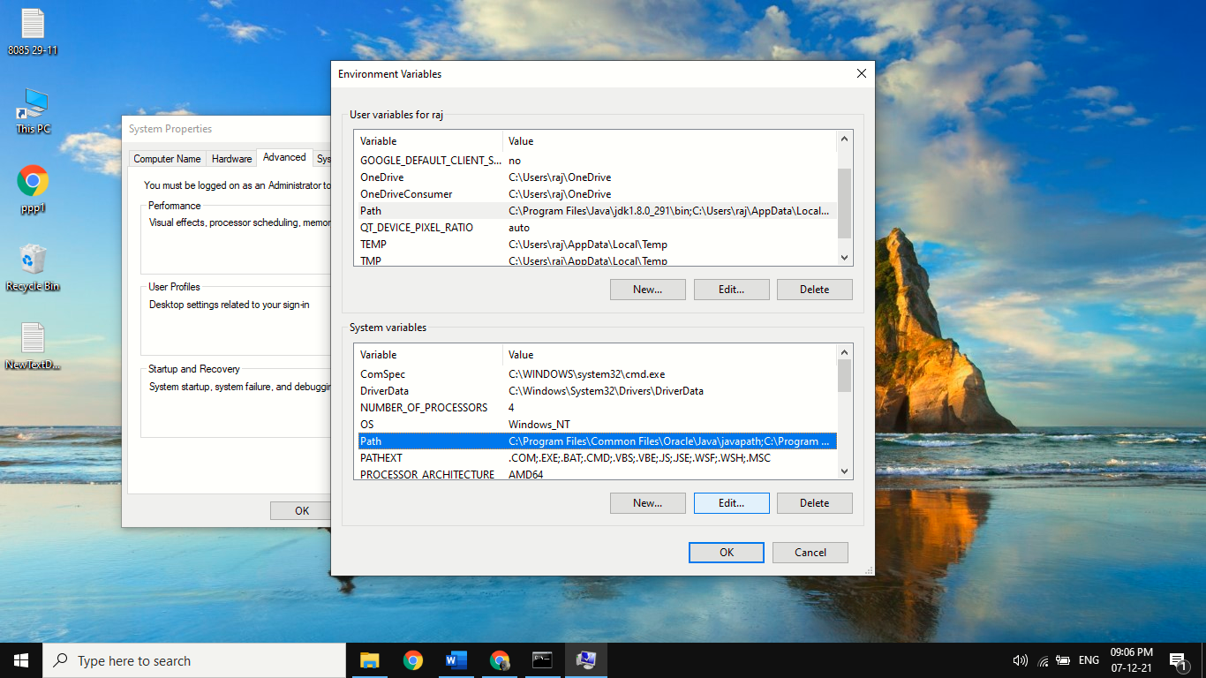

1. Click on new and paste the Path of java as show below

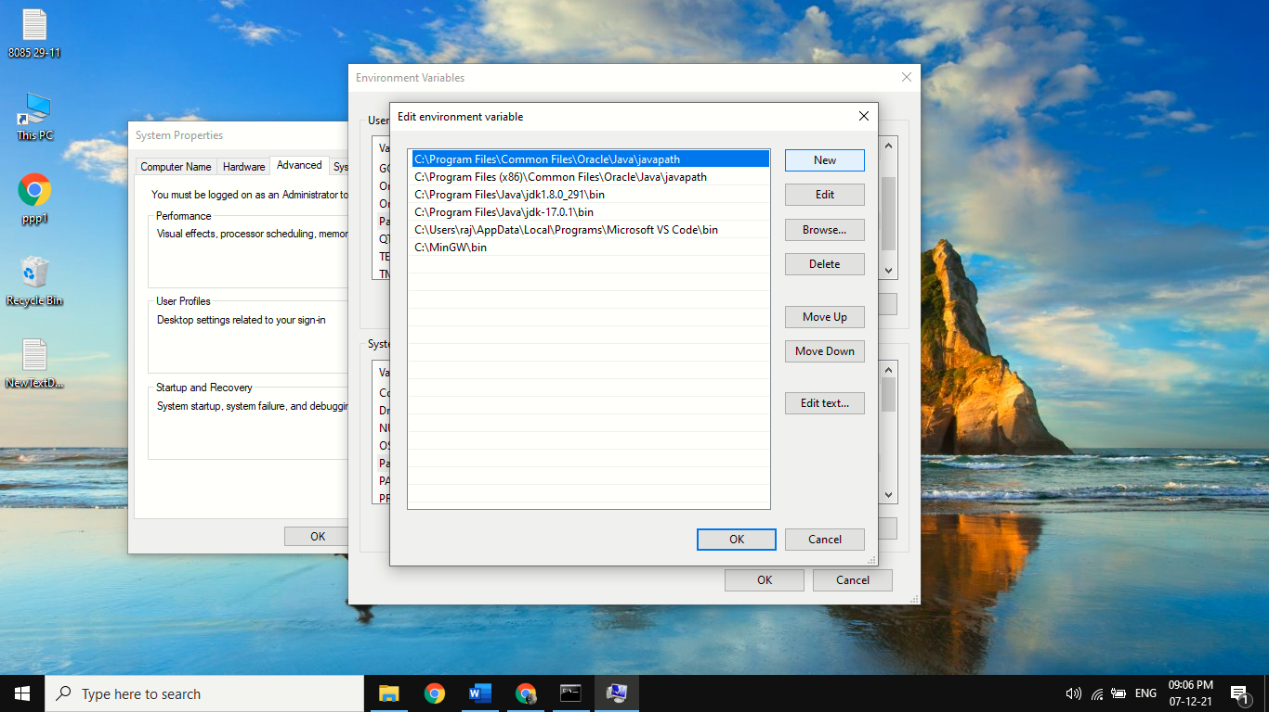

**Practical 2:**

**AIM:** **Implement a JAVA program to display “Hello World” on the console.**

**CODE:**

class hem

{

public static void main(String args[])

{

System.out.println("Hello world");

}

}

**OUTPUT:**

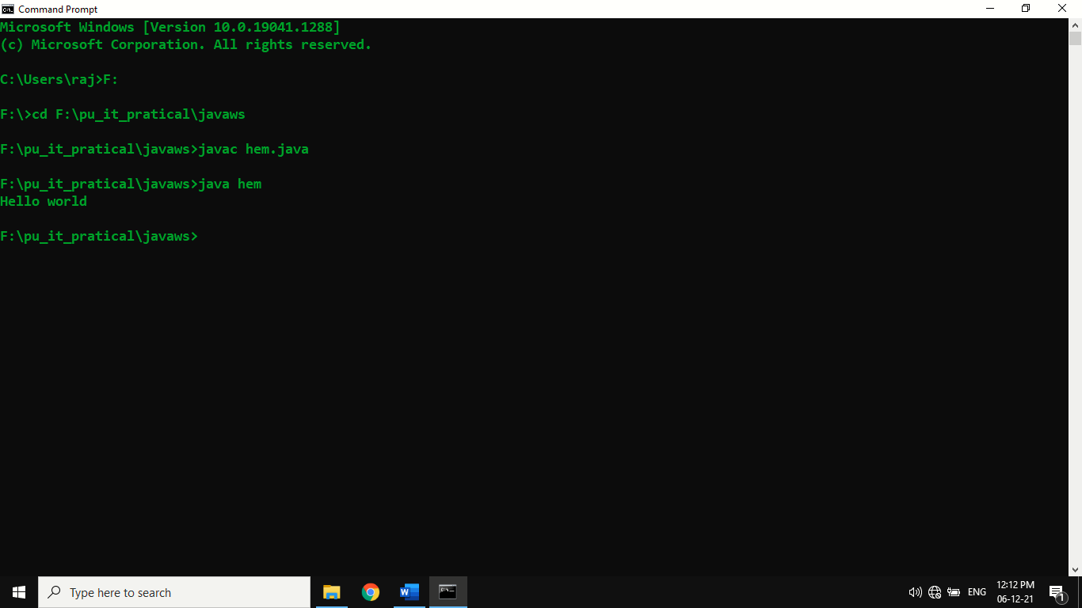

**Practical 3:**

**AIM:** **How to compile and run the above program.**

**Steps:**

1. Firstly Open The Command Line In Your Device

2. Than Go To C Or D Drive Wherever You Have Saved Your Code File.

3. Than Type Javac P1.Java To Compile And Get Class File For It

4. And Than Type Java P1 To Run The Program

**Code:**

C:\Users\raj>F:

F:\>cd F:\pu_it_pratical\javaws

F:\pu_it_pratical\javaws>javac hem.java

F:\pu_it_pratical\javaws>java hem

Hello world

**OUTPUT:**



**Practical 4:**

**AIM:** **Write a program to test number is prime or not.**

**CODE:**

import java.util.*;

class prime{

public static void main(String args[])

{

int a,p,i;

Scanner sc = new Scanner(System.in);

System.out.println("Enter Number:");

a= sc.nextInt();

p=0;

for(i=1;i<=a;i++)

{

if ( a % i == 0)

{

p++;

}

}

if(p==2)

{ System.out.println(a+" is a Prime Number"); }

else

{ System.out.println(a+" is not a Prime Number"); }

}

}

**Output:**

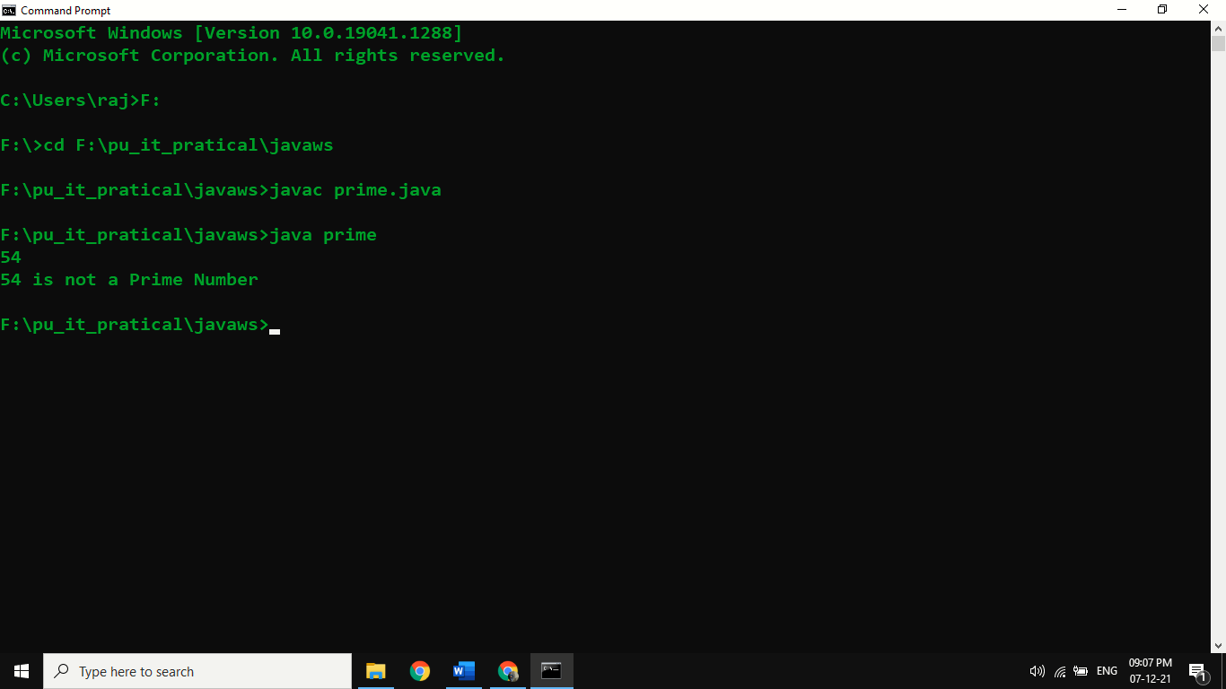

**Practical 5:**

**AIM:** **Write a program that creates and initializes a four integer element array. Calculate and display the average of its values.**

**Code:**

class array

{ public static void main(String num[])

{

int n;

double sum = 0;

for (int i = 0; i <= 3; i++)

{

n = Integer.parseInt(num[i]);

sum=sum+n;

}

System.out.println("Avg:"+sum/4);

}

}

**OUTPUT:**

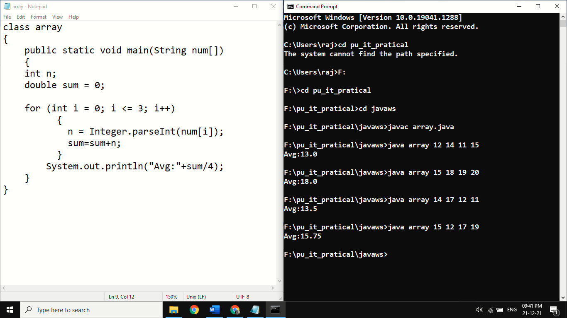

**Practical Set: 2**

**Class, object and methods in JAVA**

**Practical 1:**

**AIM:** **Write class Box**

**a. Define data member l,b,h**

**b. Define method to set the data.**

**c. Define display method to display data member**

**Code:**

class Box

{ double l;

double h;

double b;

void volume()

{ System.out.print("Volume is : ");

System.out.println(l*h*b);

} }

class box1

{ public static void main(String args[])

{ Box b1=new Box();

b1.l=22.50102;

b1.h=50.44252;

b1.b=42.52471;

b1.volume();

} }

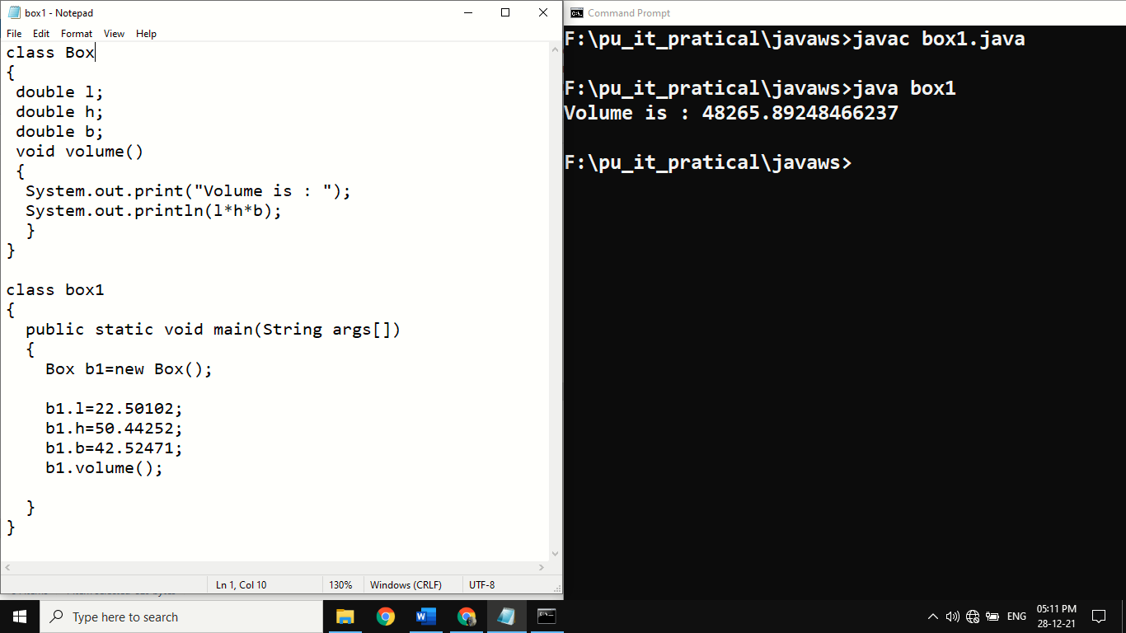**Output:**

**Practical 2:**

**AIM:**  **Write class Box**

**a. Define data member l,b,h.**

**b. Define default and Parameterized constructor to initialize value of data member.**

**c. Define display method to display data member.**

**Code:**

class Boxdem

{ double l;

double b;

double h;

Boxdem()

{ System.out.println("constucting Box");

l=11.2;b=780.7;h=93.1; }

double volume()

{ return l*b*h; } }

class Box4

{ public static void main(String args[])

{ Boxdem b1=new Boxdem();

double vol;

vol = b1.volume();

System.out.println("The volume is : " + vol);

}}

**Output:**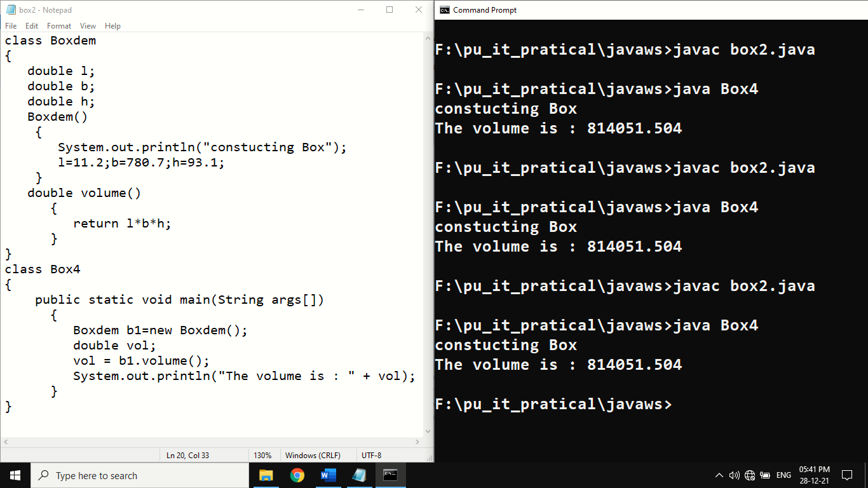

**Practical 3:**

**AIM:Write a java Program for garbage collection.**

**Code:**

class sample

{

protected void finalize()

{

System.out.println("Finalize method called by garbage collector");

}

}

class GCFinalize

{

public static void main(String[] arg)throws Throwable

{

for(int i=0;i<5;i++)

{

sample s=new sample();

System.gc(); // forcefully calling finalize() method

System.out.println("GC done");

}

}

}

**Output:** 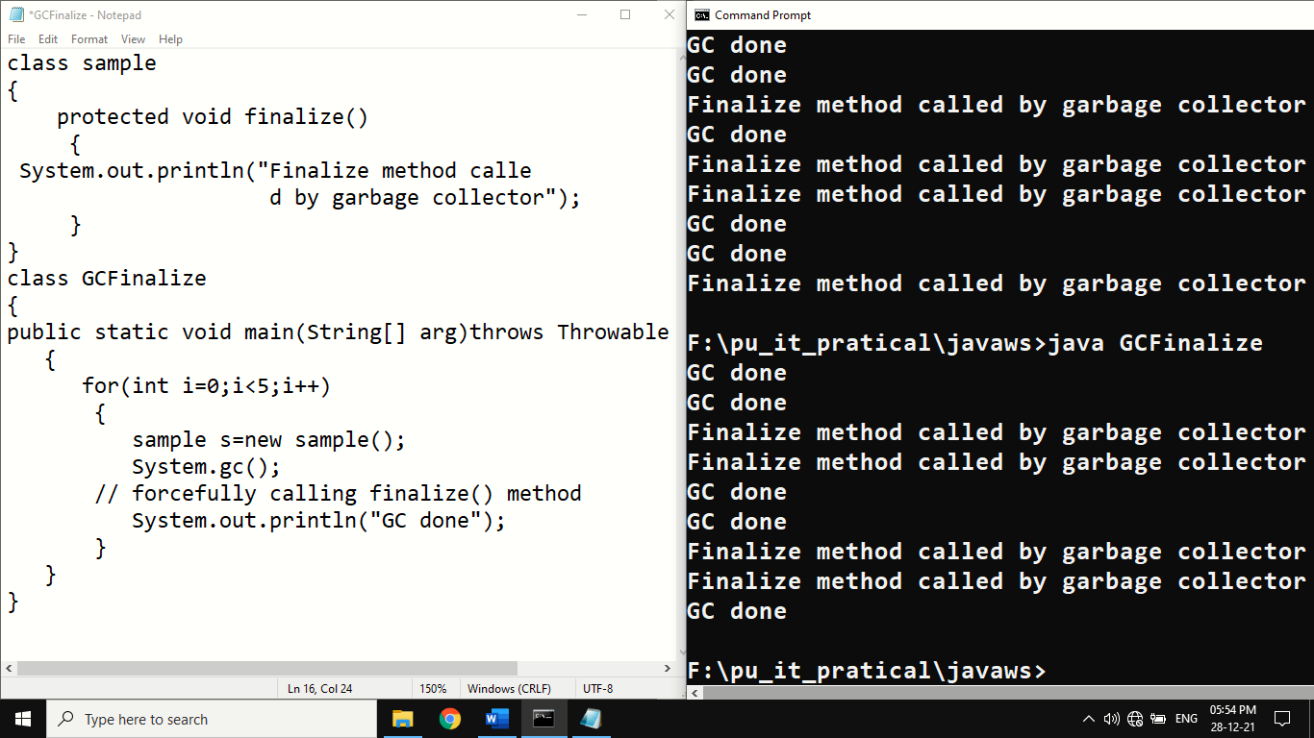

**Practical 4:**

**AIM: Write a java program to do sum of command line argument passed two Double numbers.**

**Code:**

class sum

{

public static void main(String args[])

{

double sum=0,k;

for(int i=0;i<args.length;i++)

{

k=Double.parseDouble(args[i]);

sum=sum+k;

}

System.out.println("Sum:"+sum);

}

}

**Output:**

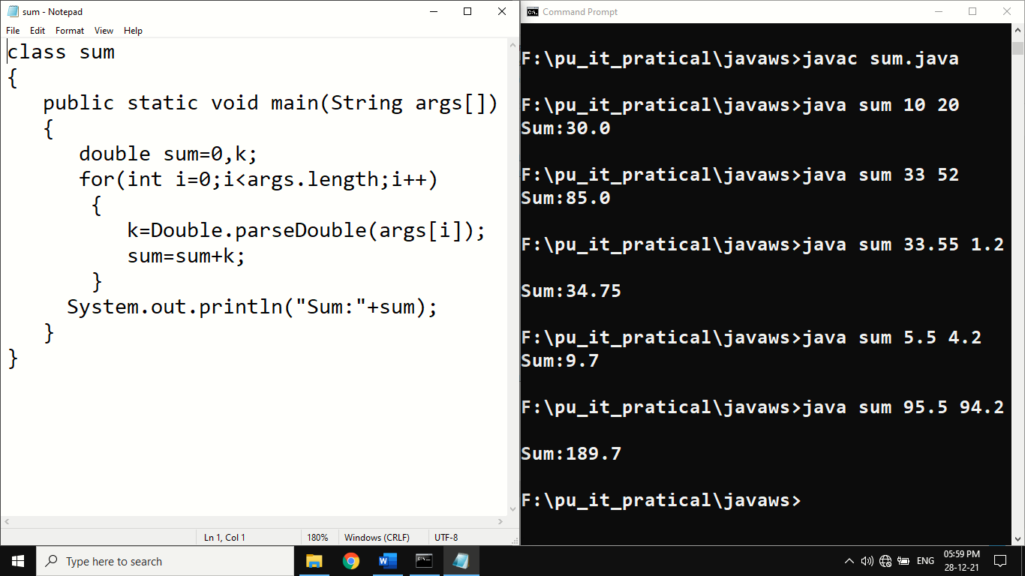

**Practical Set: 3**

**Inheritance**

**Practical 1:**

**AIM:** **Write java Program for single level inheritance.**

**Code:**

import java.util.*;

class Inheritance_multiply

{

public static void main(String args[])

{

sub sub1 = new sub();

Scanner sc = new Scanner(System.in);

System.out.print("Enter Number 1 : ");

Double a = sc.nextDouble();

System.out.print("Enter Number 2 : ");

Double b = sc.nextDouble();

sub1.setij(a,b);

sub1.multiply();

}

}

class inhertmultiply

{

Double a;

Double b;

}

class sub extends inhertmultiply

{

Double c;

void setij(Double i,Double j)

{ a=i;

b=j;

}

void multiply()

{ c=a*b;

System.out.println("Multiplication of 2 Number : "+c);

}

}

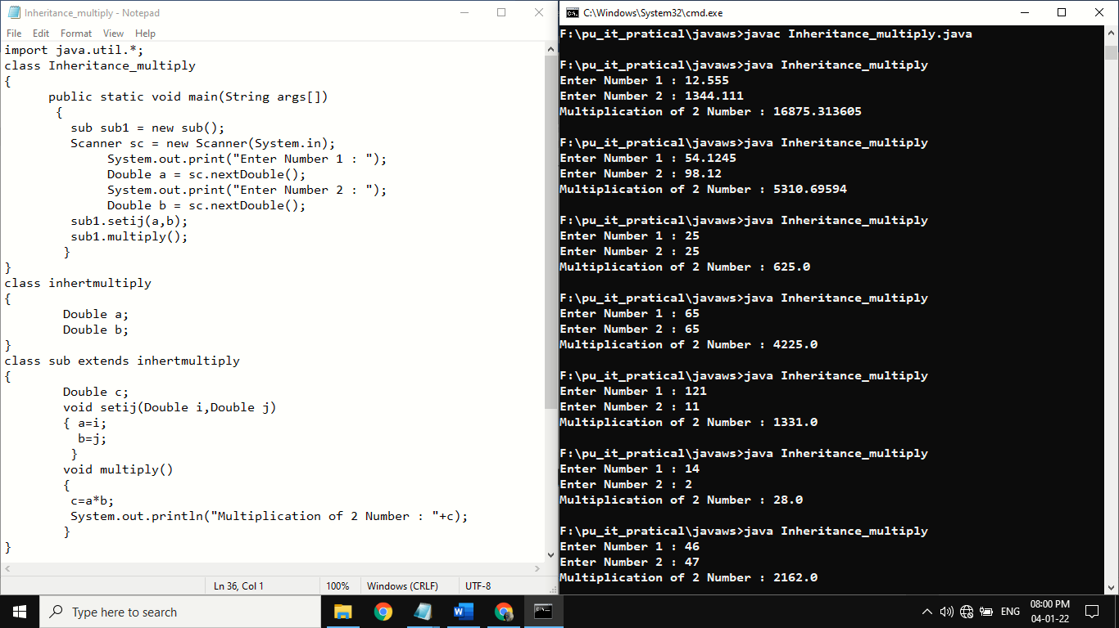**Output:**

**Practical Set: 4**

**Java Keyword**

**Practical 1:**

**AIM:** **Write java program to demonstrate the use of static keyword.**

**Code:**

class Student

{

int rollno;

String name;

static String college ="PIET";

static int count=0;

static int branchcode=545;

Student()

{

this.rollno =3;

this.name ="Hemil ";

count++;

}

Student(int r, String n)

{

rollno=r;

name=n;

count++;

}

void display()

{

System.out.println(rollno +" "+ name +" "+ college +" "+ branchcode);

System.out.println("Inserted record no." + count);

}

}

class staticConstant

{

public static void main(String args[])

{

Student s1 = new Student(3,"Meet"); //count=1

s1.display();

Student s2 = new Student(4,"Raj"); //count=2

s2.display();

Student s3 = new Student(5,"Utsav"); //count=3

s3.display();

Student s = new Student();

s.display();

}

}

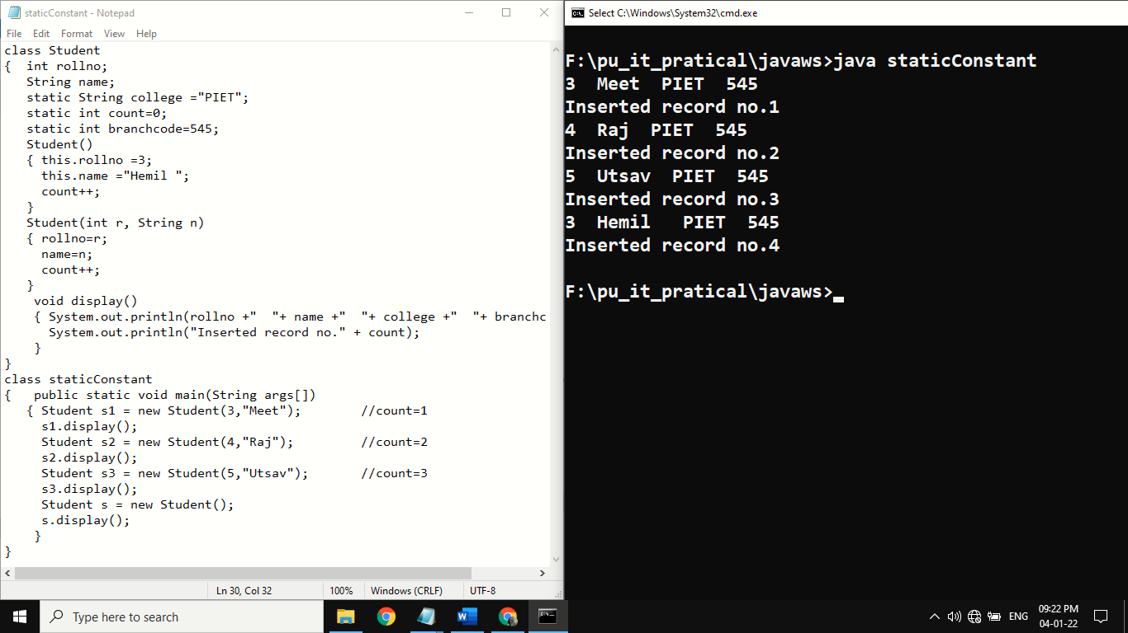**Output:**

**Practical Set: 5**

**AIM:** **Describe abstract class called Shape which has three subclasses say Triangle, Rectangle and Circle. Define one method area() in the abstract class and override this area() in these three subclasses to calculate area for specific class object.**

**Code:**

import java.util.*;

abstract class Shape1

{

double dim1,dim2,radius;

abstract double area();

}

class Triangle1 extends Shape1

{

Triangle1(double d1, double d2)

{

dim1=d1;

dim2=d2;

}

double area()

{

System.out.println("Area of Triangle is ");

return (dim1*dim2)/2;

}

}

class Rectangle1 extends Shape1

{

Rectangle1(double d1, double d2)

{

dim1=d1;

dim2=d2;

}

double area()

{

System.out.println("Area of Rectangle is ");

return dim1*dim2;

}

}

class Circle1 extends Shape1

{

Circle1(double d1)

{

radius=d1;

}

double area()

{

System.out.println("Area of Circle is ");

return 3.14*radius*radius;

}

}

class AbstractClassShape

{

public static void main(String arg[])

{

double a1,b1,a2,b2,r1;

Scanner sc=new Scanner(System.in);

System.out.println("Enter Rectangle side");

a1=sc.nextDouble();

b1=sc.nextDouble();

System.out.println("Enter Radius");

r1=sc.nextDouble();

System.out.println("Enter Triangle base and height");

a2=sc.nextDouble();

b2=sc.nextDouble();

Triangle1 t=new Triangle1(a1,b1);

Rectangle1 r=new Rectangle1(a2,b2);

Circle1 c=new Circle1(r1);

System.out.println(t.area());

System.out.println(r.area());

System.out.println(c.area());

}

}

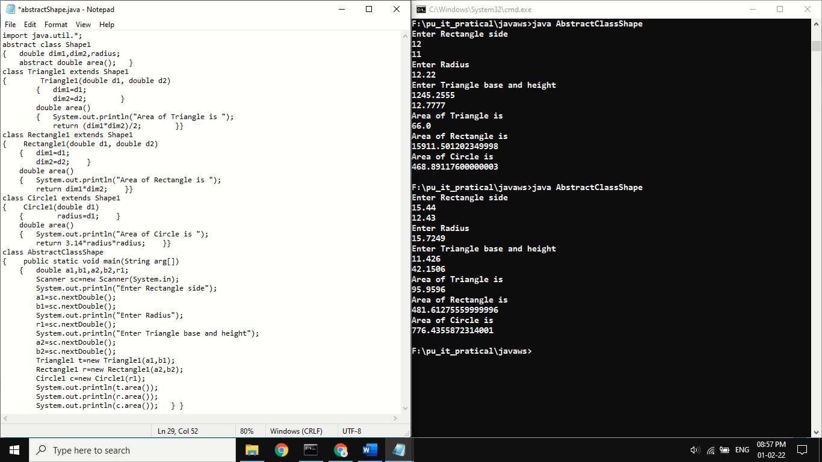**Output:**

**Practical Set: 6**

**Package**

**Practical 1:**

**AIM:** **Write java program for package.**

**Code h1.java:**

package p3;

import p2.*;

import java.io.*;

public class h1

{ public static void main(String args[])

{ h2 obj = new h2();

obj.hi();

} }

**Code h2.java:**

package p2;

import java.io.*;

public class h2

{ public void hi()

{ System.out.println("Hello");

} }

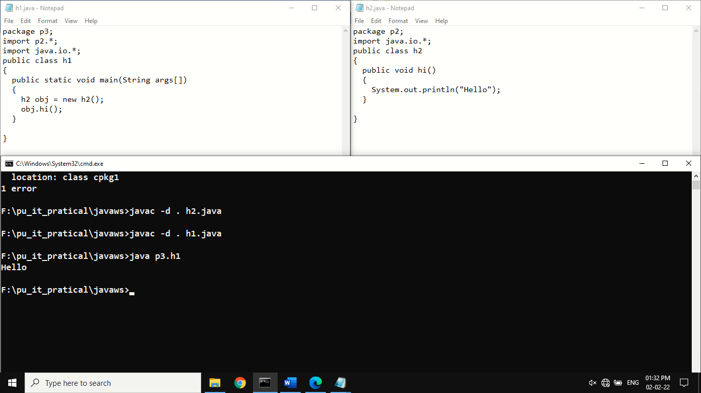**Output:**

**Practical Set: 7**

**Exception Handling**

**Practical 1:**

**AIM:**  **Write a program to show divide by zero error through exception, and also try to catch the exception.**

**Code:**

import java.io.*;

class Exception {

public static void main(String[] args)

{

try {

int number;

number = 30 / 0;

}

catch (ArithmeticException e) {

System.out.println(

"Zero cannot divide any number\n"+e);

}

}

}

**Output:**

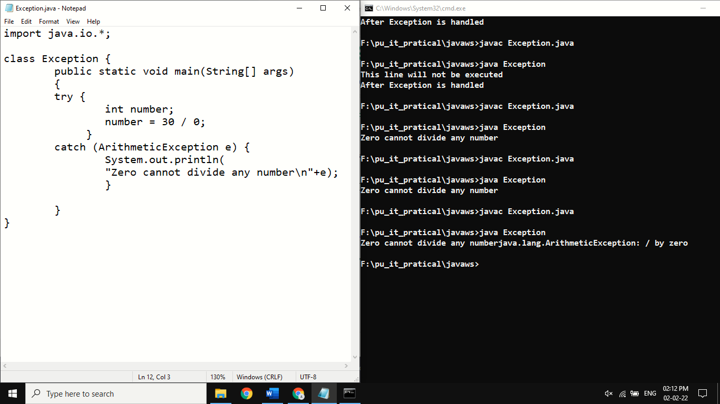

**Practical Set: 8**

**Concurrent Programming**

**Practical 1:**

**Aim:** **Write a program to demonstrate thread using Thread class and Runnable interface.**

**Code:**

class DemoTh implements Runnable

{

public void run()

{

System.out.println("Started running new using runnable interface");

}

}

class MThread

{

public static void main(String args[])

{

DemoTh t=new DemoTh();

Thread t1= new Thread(t);

t1.start();

System.out.println("Concureent program");

}

}

**Output:**

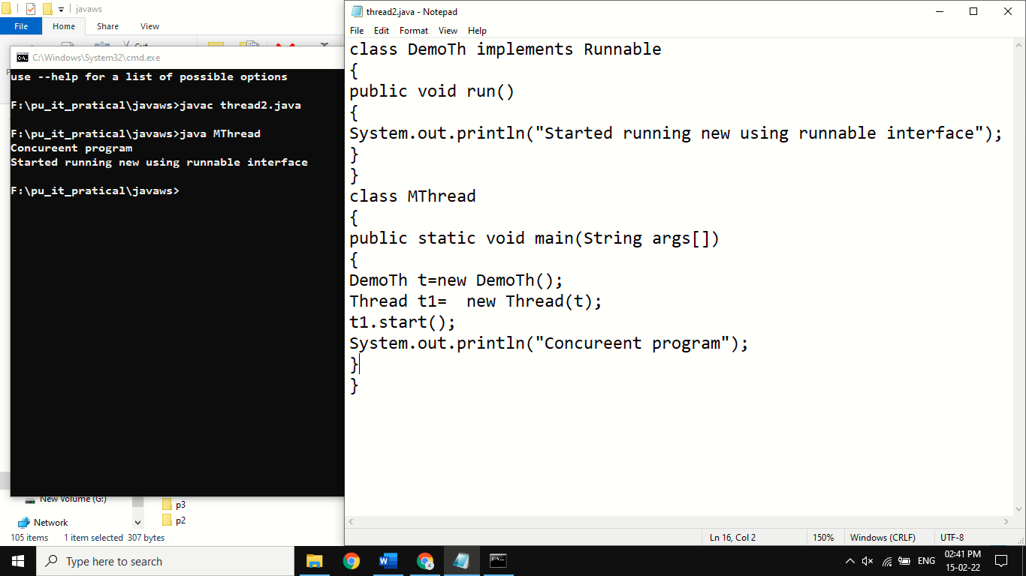

**Practical Set: 9**

**IO Programming**

**Practical 1:**

**Aim:** **Write a Java program to copy content of file1.txt to file2.txt using Java file handling.**

**Code:**

import java.io.BufferedReader;

import java.io.File;

import java.io.FileReader;

import java.io.FileWriter;

import java.io.IOException;

class FileCopy

{ public static void main(String[] args) throws IOException

{

File fsrc = new File("x.txt");

File fdes = new File("y.txt");

FileReader fr=new FileReader(fsrc);

BufferedReader br= new BufferedReader(new FileReader(fsrc));

FileWriter fw = new FileWriter(fdes);

String s= null;

while((s=br.readLine()) != null)

{

fw.write(s);

fw.write("\n");

fw.flush();

}

fw.close();

}

}

**Output:**

